Building A Machine Learning Model for Crime Prediction and Exploring Relevant Factors

Research Objectives
This study aims to provide new insights on the West Yorkshire crime data by:
- Exploring current methods and their application.
- Investigating any correlations or regression between different aspects of criminal activity.
- Using data mining and decision trees to highlight new patterns in the crime data.
- Determine an accurate model to predict where crimes are likely to be, and when they are likely to occur.

Data Collection
The dataset used in this study was obtained via open-source available on https://data.police.uk ranging from 2018 to January 2024 and contained 1,048,575 rows and 12 Columns with CSV extension. To ensure the quality and accuracy of the data, the dataset was thoroughly selected and cleaned. Figure 2 below shows the data types in the data frame: data objects holding string, numeric or Boolean data and numeric float64, capable of holding the lengthy numeric sequence in longitude and latitude grid references.

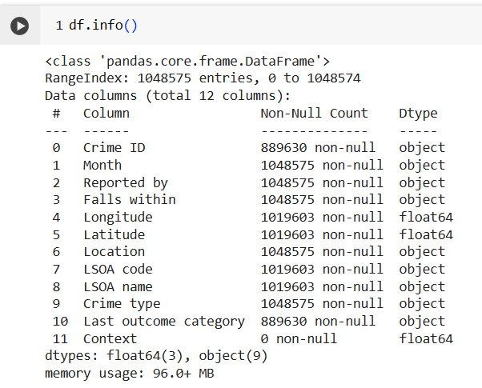

Data Cleaning
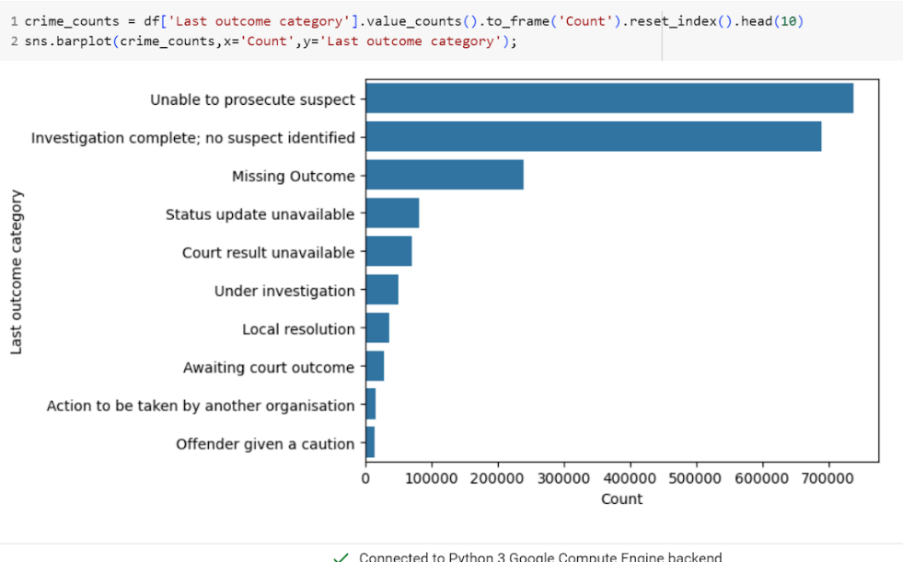

Geographic Location
The dataset contained latitude and longitude coordinates which provides a visualisation of where the crime hotspots were located on a given date. For the purposes of the study, all crime types were included in figure 9 below, however it is possible to base this on a chosen crime type. Further analysis on crime types by West Yorkshire district have been included in Appendix B.

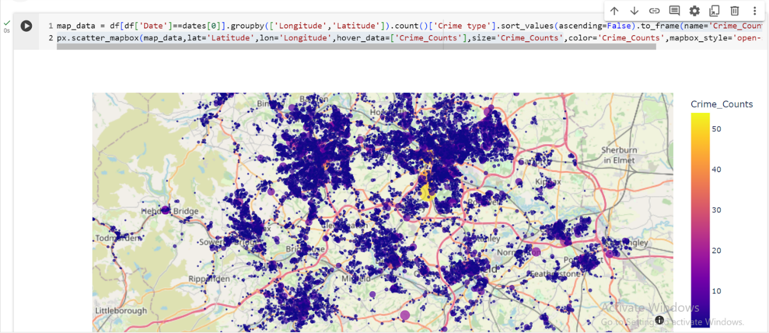
Crime heat-map.
Additionally, crime location provided an insight into the number of crimes occurring on or near certain premises on a given month. As shown in figure 10 below, the most common premises in the month of February were either on or near a supermarket, or where no location was recorded. There was an emphasis on inconsistent documentation across different locations, with some places like supermarkets having detailed records while others did not.
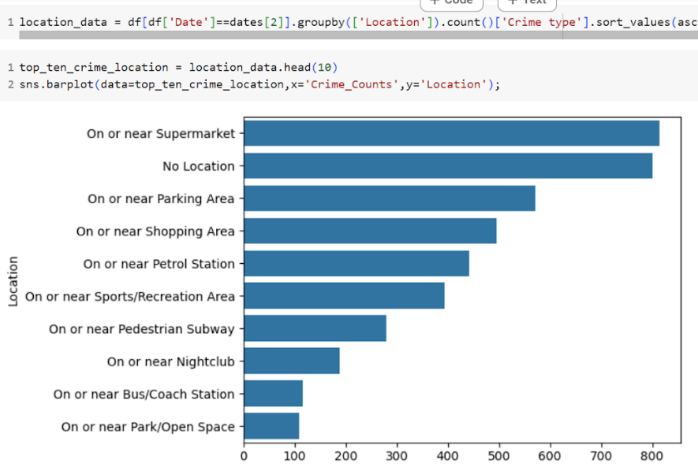
Count of crimes per crime location on a given month (February).
The number of crimes in a given month for all crimes showed that Violence and sexual offences continued to dominate monthly crime statistics, raising concerns about the prevalence of these crimes.

Correlation
The data suggests that there may be significant discrepancies or anomalies in how crimes are documented versus actions taken, though specifics on correlation coefficients or analysis methods were not provided.
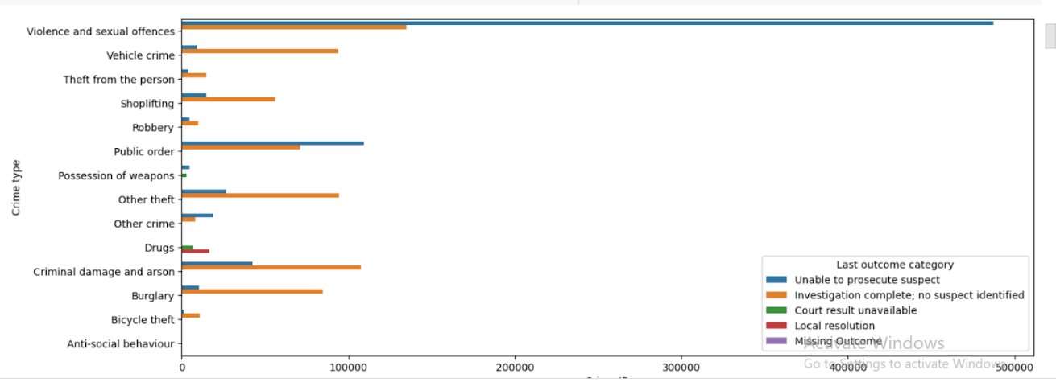
Correlation between crime type and action taken.
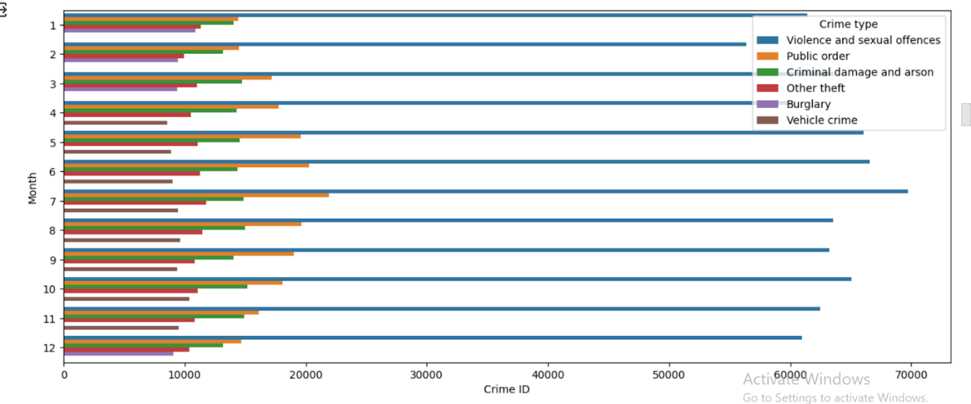
Figure 12: Correlation between crime type and month.
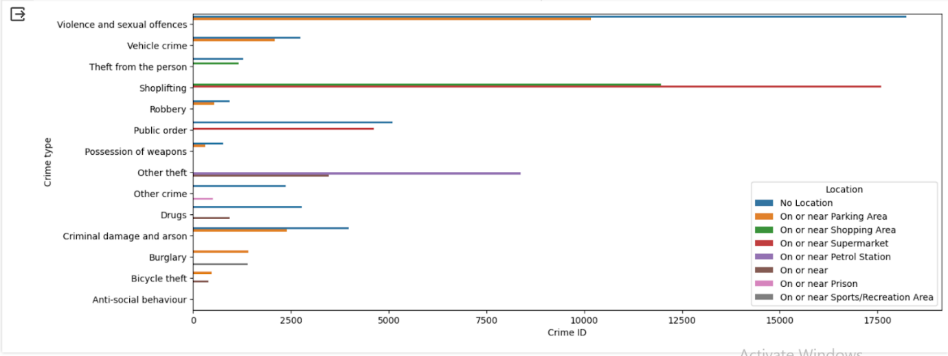
Correlation between crime type and crime location.

